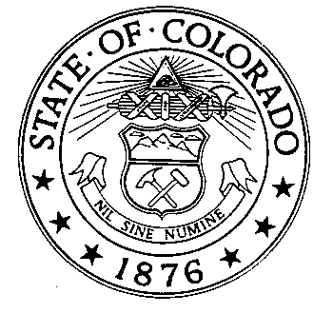
Ken Salazar  Attorney General  Christine M. Arguello  Chief Deputy Attorney General  Alan J. Gilbert  Solicitor General | STATE OF COLORADO  DEPARTMENT OF LAW  Office of the Attorney General | State Services Building  1525 Sherman Street - 5th Floor  Denver, Colorado 80203  Phone (303) 866-4500  FAX (303) 866-5691
April 1, 2002

The Honorable Joel Hefley
Chairman
United States House of Representatives
Committee on Armed Services’ Subcommittee
on Military Readiness
2230 Rayburn House Office Building
Washington, D.C. 20515-0605

Dear Chairman Hefley:

Thank you for the opportunity to submit written testimony regarding the impact of environmental regulation on military readiness. Enclosed are several pieces of correspondence that the National Association of Attorneys General has sent over the years. This correspondence is indicative of the states' concerns with federal agencies' -- and more specifically, the Department of Defense's -- compliance with state and federal environmental laws. In addition to this correspondence, we would like the Committee to consider the following observations.

First, we absolutely support maintaining our Nation's military preparedness. We recognize that maintaining military readiness requires that the armed forces receive regular realistic training, and that the military be able to test and evaluate weapons systems and other military equipment under realistic conditions. We also recognize that "external" factors such as urban and suburban sprawl, have impacted the Department of Defense's training, testing and evaluation activities. And we are aware of isolated cases where requirements imposed under the pollution control laws may have affected military operations. At the same time, we are concerned that DOD's training, testing and evaluation activities obviously do have environmental impacts. The question is how to conduct these activities in a manner that maintains readiness while ensuring protection of human health and the environment.

The states are the primary implementers of the nation's pollution control laws. We think that the existing framework of these laws is sufficiently flexible to provide for balancing of environmental and readiness concerns. There is a great deal of flexibility built in to the different regulatory programs, as the Department's own testimony has demonstrated. As we understand the Department's testimony, it is concerned about the cumulative impact of environmental, health and safety restrictions on military readiness, and fears that these impacts will increase. However, the environmental laws already allow either the President or the Secretary of Defense to exempt the Department of Defense from their statutory and regulatory requirements on a case by case basis. All that is required is a finding that doing so is necessary for national security or is in the paramount interests of the United States, depending on the particular statute at issue. Such exemptions exist under the Clean Air Act, Clean Water Act, Resource Conservation and Recovery Act (RCRA), Comprehensive Environmental Response, Compensation and Liability Act, and Safe Drinking Water Act. We understand that to date, these exemption provisions have only been invoked twice, and neither instance involved military training activities.

Other provisions of the environmental laws provide further flexibility to balance environmental protection with other federal priorities. For example, in 1992, Congress provided EPA authority to issue administrative orders under RCRA to other federal agencies, but required that such agencies have the opportunity to confer with the EPA administrator before any such order became final. Congress passed a similar amendment to the Safe Drinking Water Act. And Congress has already spoken to the balance between environmental protection and management of waste military munitions. In 1992, Congress rejected a bill that would have authorized the Secretary of Defense to promulgate regulations governing the safe development, handling, use, transportation, and disposal of military munitions. Instead, it directed the Environmental Protection Agency to consult with the Secretary of Defense prior to issuing regulations that define when military munitions become wastes for purposes of RCRA.

Finally, in 1997, Congress created a procedure that allows the Secretary of Defense to temporarily suspend any pending administrative action by another federal agency that the Secretary determines "affects training or any other readiness activity in a manner that has or would have a significant adverse effect on the military readiness of any of the armed forces or a critical component thereof." During the suspension, the Secretary and the head of the other federal agency must consult attempt to mitigate or eliminate the adverse impact of the proposed action on readiness, consistent with the purpose of the proposed action.

We understand that the Department plans to propose legislative changes to the environmental laws. We believe that any such changes should be considered very carefully. The history of federal facility compliance with environmental laws demonstrates that statutory constructs that rely on voluntary efforts by federal agencies to achieve environmental objectives simply do not work. Even when Congress has clearly stated its intent that federal agencies be subject to state and federal environmental laws, the federal agencies have frequently resisted efforts to require them to comply. The history of the Clean Air Act provides a good example. Before 1970, the Clean Air Act encouraged, but did not require, federal agencies to comply with its mandates. Congress determined that this voluntary system was not working, and in 1970 amended the act to require federal agencies to comply. Specifically, Congress added section 118 to the Clean Air Act. The first sentence of the section provides, in relevant part:

Each department, agency, and instrumentality of . . . the Federal Government . . . shall comply with Federal, State, interstate, and local requirements respecting control and abatement of air pollution to the same extent that any person is subject to such requirements.
42 U.S.C. § 1857f. The 1970 amendments also required the Environmental Protection Agency to establish ambient air quality standards. Each state had to submit plans describing how the state would meet these standards. Kentucky, like most states, submitted a plan that relied on permits as the sole mechanism to establish emissions limitations for air pollution sources, and to establish schedules for achieving compliance with the emissions limitations. Kentucky sought to require several federal facilities (including the Army's Fort Knox, Fort Campbell and others) to obtain permits. The federal agencies refused, arguing that section 118 of the Clean Air Act did not obligate them to comply with "procedural" requirements, such as the need to obtain state permits. Without the permit, there was no way for Kentucky to control air pollution from these federal facilities. The matter went to court, and ultimately the Supreme Court agreed with the federal agencies. Shortly thereafter, Congress amended the Clean Air Act to require federal agencies to comply with procedural requirements, including permit requirements.

Even when Congress has plainly required federal agencies to comply with state and federal environmental laws, the federal agencies have worse compliance records than private industry. The sole exception is under RCRA. In 1992, the Supreme Court held that federal agencies were not subject to penalties for violating state hazardous waste and water quality laws. That same year, Congress amended RCRA to make federal agencies subject to penalties for violating hazardous waste laws. Since 1992, DOD and other federal agencies have steadily improved their RCRA compliance rates, to the point where they now have a higher compliance rate than private industry.

This salutary trend stands in stark contrast to federal agency performance under the Clean Water Act. Unlike RCRA, Congress has not amended the Clean Water Act to subject federal agencies to penalties for violating Clean Water Act requirements. The percentage of DOD facilities in significant non-compliance with the Clean Water Act has steadily risen over time. Similarly, DOD has long had a higher rate of significant non-compliance with Clean Water Act requirements than private industry, or even civilian federal agencies.

Thus, we are concerned that providing the Department of Defense statutory exemptions from environmental laws will have adverse impacts on human health and the environment. But such exemptions will have other undesirable impacts as well: substantially increased costs to "remedy" environmental contamination, and greater constraints on use of training ranges. As we stated in our May 31, 2001 letter regarding encroachment, prevention is by far the most effective and least costly means of ensuring environmental protection. It also is a necessary component of sustainable range management. The Department, and the nation, cannot afford to repeat the experience at the Massachusetts Military Reservation (MMR) at other ranges around the country. There, decades of military training activities have contaminated over 60 billion gallons of groundwater in the sole source aquifer for Cape Cod. This contamination led EPA to suspend most live-fire military training at the MMR artillery range pursuant to its Safe Drinking Water Act authority. Subsequently, the state of Massachusetts and the Army reached an agreement, now embodied in state law, that balances military training needs and environmental protection. The plain lesson here is that ignoring environmental consequences of military training benefits neither the environment, public health, nor military training.

In conclusion, resolving the increasing pressures on military training activities in a manner that protects human health and the environment, while ensuring military readiness, demands creative thinking. The issues involved are many and complex. They would benefit from an open discussion among a full range of affected parties. The states, as the primary implementers of the nation's environmental laws, must play a key role in arriving at any solutions. We thank the Committee for this opportunity to express our views.

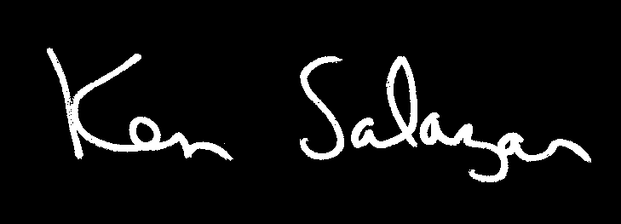

Ken Salazar
Attorney General of Colorado
NAAG, Chair
Environment Committee

