Playa Vista
Los Angeles, California
Lenny Siegel
Summer, 2006

On July 18, 2006, I visited Playa Vista, at nearly 1,100 acres one of the largest developments in the history of Los Angeles County, California. My host was activist Patricia McPherson, of the Grassroots Coalition (http://www.grassrootscoalition.org). McPherson and many others, including my parents, have opposed and/or criticized Playa Vista for its impact on one of the last remaining wetlands areas in Los Angeles, the massive seepage of methane gas from underground, and other problems, including toxic contamination.

On September 12 I met with officials from the Los Angeles Regional Water Quality Control Board (LARWQCB), the agency principally responsible for environmental cleanup at the site, and reviewed documents pertaining to volatile organic compounds at the site.

When I grew up in Culver City, just a few miles away, I knew the property as Hughes Aircraft. The flat area north of the Westchester bluffs and (a little further away) the Los Angeles International Airport contained its own airstrip. Indeed, one of the features of the new development is the historic hangar in which Hughes built the giant wooden aircraft known as the Spruce Goose.

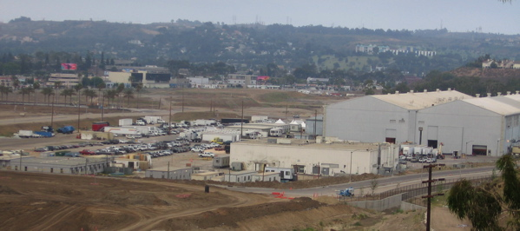

Historic Hughes hangars

After Hughes and its corporate successors stopped manufacturing on the site, the hangars were used for movie production. In the late 1990s (or maybe later), developers proposed a massive new community, to contain several thousand housing units, offices, and commercial development. A collection of environmental and other community groups, including McPherson’s, organized in opposition. They challenged the scale of the development and the traffic it would generate, and they called instead for restoration of the historic wetlands ecosystem of the Ballona Marsh.

In 2002, the developers proposed a scaled-back development, and today the first phase, with 3,200 housing units, is nearly complete. Today its web site (www.playavista.com) touts a “new urbanist” lifestyle, and it advertises the restored Ballona Freshwater Marsh. The wetlands once covered more than 2,000 acres in the Playa Vista, Marina Del Rey, and Venice sections of Los Angeles. Now only about 200 acres remain.

Opponents warn that methane seeping from underground is an enormous threat to the safety of the occupants of present and future buildings. The local NBC affiliate, KNBC-4, won a Peabody Award for “Burning Questions,” a four-part 2005 news series featuring McPherson and her scientific advisers, documenting the methane problem. In October, 2005 opponents won a California Appellate Court ruling in which the court ordered the City of Los Angeles to follow the California Environmental Quality Act and to reconsider the methane mitigation measures built into the original buildings. Thus far, critics have successfully blocked the construction of a new school in a methane-susceptible area.

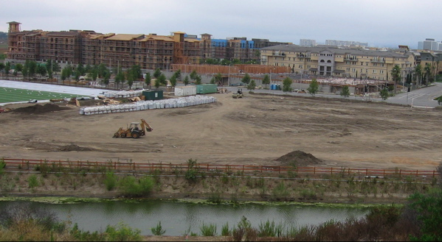

Proposed school site

Much of the methane debate centers upon whether the source is natural—much of West Los Angeles is an old oilfield—or the result of leakage from Southern California Gas Company’s underground gas storage reservoir. In my view, the more important question is whether the mitigation systems of plastic lining and ventilation built into the new buildings are adequately containing the methane. KNBC and the Grassroots Coalition have demonstrated mitigation system failures, in which methane vapors intruded into at least some of the Playa Vista buildings.

While the debate over methane intrusion has been going on for some time, little public attention has been paid to the toxic groundwater contamination typical of aerospace production and airfields. The shallow aquifer under parts of the property contains TCE (trichloroethylene), vinyl chloride, and BETX (benzene, ethylbenzene, toluene, and xylene) in the thousands of parts per billion. The contaminant of greatest concern seems to be vinyl chloride, formed by the apparent biodegradation of TCE .

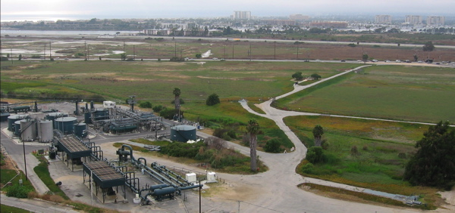

The aboveground features of the gas storage facility

The Playa Vista site has been undergoing remediation for more than a decade, under the supervision of the LARWQCB. The developer has employed innovative in situ technologies, and the Water Board has designated the state drinking water standards as long-term remediation goals. However, it has also accepted, with minor qualifications, less protective, site-specific Health-Based Remediation Goals (HBRGs) proposed by the developer’s consultant and reviewed by California’s Office of Environmental Health Hazard Assessment. The HBRGs supposedly take into account the vapor intrusion pathway, the potential migration of volatile compounds from the subsurface into overlying structures.

Each segment of the property must meet those standards before development may occur. That is, construction is permitted when soil, groundwater, and soil gas measurements of vinyl chloride and other contaminants falls below the HBRGs, even while cleanup systems continue to pursue the legally mandated groundwater goals. Furthermore, the developer has agreed to use the HBRGs created for residential—that is, unrestricted—use, and to build mitigation into its structures. The Water Board would require institutional controls—legally binding activity and use limitations—if residential HBRGs are not met.

There are several vinyl chloride hot spots on the property. The highest concentrations—in the thousands of parts per billion—are in the “Campus Area,” the area including the historic hangars. According to Water Board officials, no construction has occurred directly over those hot spots. According to McPherson, there is still an active proposal to construct a new school on or near the old Hughes fire training burn pit, but that—under California’s school review law—is being evaluated by another agency, the Department of Toxic Substances Control.

In my view, the application of a second set of remediation goals to approve construction over the toxic hot spots is innovative, and on its surface, a good way to balance the objectives of property use and environmental protection. However, the HBRGs for vinyl chloride are surprisingly high (weak). The residential-scenario vinyl chloride groundwater HBRG is 26.5 parts per billion (ppb). The soil-gas HBRG for vinyl chloride is 3,710 micrograms per cubic meter (µg/m³). At these levels, I believe, unacceptable concentrations of vinyl chloride could migrate into overlying structures.

Conceivably, the vapor mitigation measures being designed into new buildings could protect occupants, even from high subsurface levels of vinyl chloride and other compounds. But vapor membranes can be perforated during construction or by subsequent human or natural activity. Because they have been employed only in recent years, we don’t know how long they will remain effective. Furthermore, experience elsewhere suggests that it difficult to predict vapor intrusion from groundwater and external soil gas concentrations, both because of geospatial heterogeneity in the soil and the fact that buildings tend to increase the forces that pull up toxic vapors.

Therefore, in my opinion, the only way to ensure that the occupants of buildings at Playa Vista are not exposed to unacceptable levels of volatile organic compounds is to periodically test the indoor air in those buildings until the residual contamination beneath them is reduced to legal standards—not the HBRGs. Existing buildings, in which artists currently work, should be sampled as well. It may be that methane-monitoring equipment can demonstrate that no vapor intrusion is occurring, but only in those areas with high methane levels. Where vapor barriers fail, additional mitigation, such as active subslab ventilation or positive air pressure systems, should be required.

The intrusion of toxic vapors into homes and other structures is not the only issue at Playa Vista. It’s not the reason that a broad coalition of activists continues to oppose the project. But it is an issue that has escaped public notice, and I’m concerned, without more stringent HBRGs and recurring indoor air sampling, that residents and other building occupants may be exposed to unsafe levels of vinyl chloride and other toxic compounds.

