Morris Canal Area, Jersey City, New Jersey
Lenny Siegel
June, 2006

On June 9, 2006, I re-visited the Morris Canal area in Jersey City, New Jersey, and met with June Jones-Hawkins, leader of the Morris Canal Redevelopment Area Community Development Corporation (MCRACDC). I first visited the area in 2002 as part of joint research project on local government and Brownfields, in which CPEO worked with the International City/County Management Association. In 2004 CPEO teamed with the city of Jersey City to hold a workshop on Community-Led Brownfields Revitalization.

The Morris Canal area, also known as the Lafayette neighborhood, is just outside Liberty State Park. The multi-racial neighborhood is home to many families that have lived there for generations. Part of the area is industrial. Other sections are mixed industrial, commercial, and residential. Like much of Jersey City, most of the developable property suffers from some type of soil contamination.

The MCRACDC began ten years ago as a neighborhood coalition. Jersey City actually wrote the organization into its redevelopment plan, and it incorporated as a Community Development Corporation in 1999. When Jersey City first won a Brownfields Pilot Assessment Grant from EPA, it promised a comprehensive program of community involvement. When it reportedly failed to live up to those promises, EPA threatened to pull the grant.

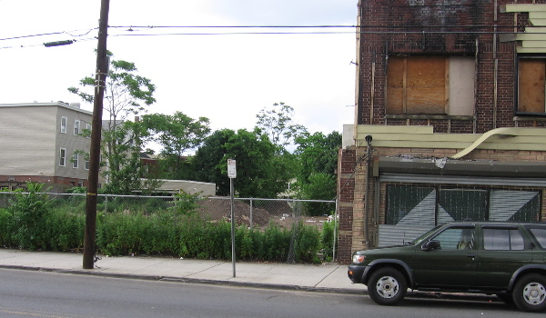

Planned site of 35 affordable condos on Communipaw Avenue

Though some in Jersey City’s government only saw the community organization as an oversight group, neighborhood leaders have always wanted more. They wanted to develop their own projects, and they wanted concessions such as a affordable housing set-asides to help counter gentrification in an area becoming more and more desirable due to its proximity to New York City’s financial district, just across the Hudson River.

When I first met Lafayette neighborhood leaders, I was skeptical. After all, they seemed to lack development expertise, and they definitely lacked capital. However, the strong turnout by and long attention span of local residents—at meetings I attended in both 2002 and 2004—convinced me that they had the ingredients of success. With the support of some key local officials, they persisted, and they are close to breaking ground on three projects.

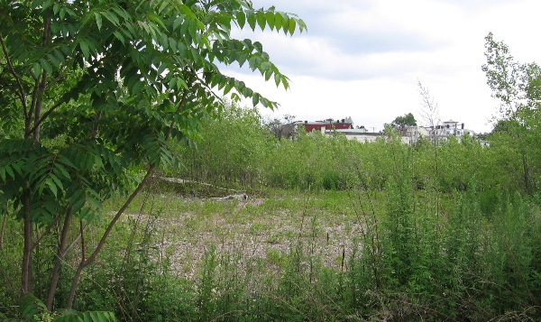

Mixed-use development site at 100 Monitor Street

As I understand it, MCRACDC is scheduled to receive two properties that have been, or are being acquired, by the Jersey City Redevelopment Agency. In cooperation with Landmark Developers, a private, locally based firm, it plans to build 39 affordable homes on those two properties. In addition, Landmark will clean and develop another, higher-value property, adjacent to a light rail station, with both housing and retail space. Landmark has promised to share its profits from that site with MCRACDC, to set aside a significant fraction of the units as affordable, and give the community the option of setting up a children’s day care center on the property.

The three projects have not yet been built, and the community has encountered unexpected roadblocks before. Nevertheless, it appears that a clear vision and hard work will pay off for the MCRACDC.

