Athens, Georgia
By Lenny Siegel
November, 2006

On September 23, 2006 I visited Athens, Georgia. My host was Jill McElheney, founder of Micah’s Mission, a faith-based ministry to improve childhood and adolescent health. McElheney began her work several years ago when her son Jarrett, now 12, was diagnosed with acute lymphocytic leukemia. Jarrett has recovered, but his mother has continued her children's environmental health mission throughout northeast Georgia. She has worked closely with some of the residents of Pittard Road, a street in Winterville with above average incidences of cancer.

McElheney has been monitoring potential vapor intrusion sites in her area. She drove me through her former neigborhood, where her son was diagnosed with cancer. It is now an under-construction housing development, where new homes are being built above a carbon tetrachloride plume. The contamination appears to emanate from a nearby grain elevator site or an adjacent petroleum pipeline facility. The chemical had been used as a fumigant and metal degreaser. She had contacted the state environmental protection division because she knew of no special attention being given to protect future residents from carbon tet vapors. The state is now working with the developer on a vapor barrier plan.


New housing, with grain elevators barely visible through the trees

But the main focus of my visit was Nakanishi Manufacturing Corporation’s ball-bearing plant in Winterville. Nakanishi is not a brownfield. There is no reported groundwater plume. But it is Georgia’s largest reported source of trichloroethylene (TCE) emissions, accounting for almost half the state’s total. In fact, it’s one of the top dozen TCE emitters in the country, releasing more than 100,000 pounds of the substance into the atmosphere each year. The company uses TCE as a degreaser.

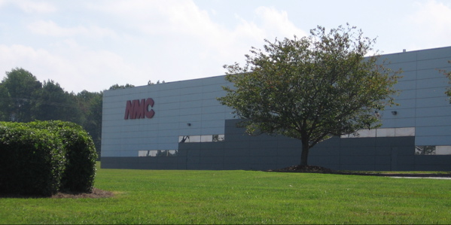

Nakanishi’s attractive, clean-looking plant

This site illustrates that communities are not just concerned about vapor intrusion and indoor air. They care about exposures, wherever they occur. Nakanishi‘s modern-looking facility is within a half mile of Coile Middle School, the New Grove Baptist Church, a Baby Boutique business, and a number of homes. The Pittard Road community is about a mile away. Activists, concerned that TCE emissions might be responsible for cancers and other diseases in the area, have challenged Nakanishi’s air permit application at public meetings, petitioning all the way to the EPA Administrator in Washington, DC. In September 2005 about 50 people marched in protest outside the plant.

State officials approved the permit, concluding that TCE exposures would not exceed the 5 microgram per cubic meter state standard, based upon modeling. But McElheney and residents were not convinced. They prevailed upon the nearby University of Georgia to collect actual air samples, indoors and out. Under the direction of toxicology professor Jeff Fisher, a nationally regarded TCE expert, university students took samples throughout the area.

Fisher's students found that the average indoor air reading exceeded 1 microgram per cubic meter, and that the average outdoor level fell just under 1 microgram per cubic meter. Peak findings, indoors and out, approached 5 micrograms per cubic meter. While the results show compliance with Georgia’s air regulations, the ambient air concentrations of TCE are among the highest in the U.S.

There is growing evidence that official standards, such as Georgia’s 5 micrograms per cubic meter level, are not fully protective of susceptible populations. And in much of the country, manufacturers have eliminated their use of TCE. Nakanishi officials, however, have contended that substitution was impractical.

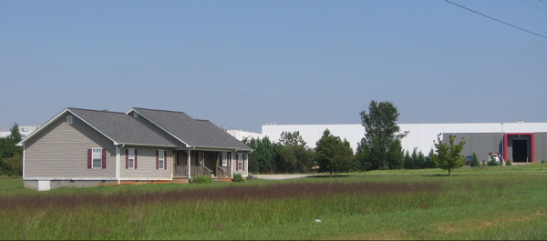

Residence near the rear of Nakanishi

Finally, though, in early November, Nakanishi sought state permission to install machinery that uses an alternative solvent, Isopar L. If the new technology meets production specifications, the company may phase out its TCE use.

In Georgia, government officials continue to calculate and approve allowable levels of pollution, even for substances such as TCE that probably cause cancer and numerous other serious health impacts. But community activists have taken the precautionary principle into their own hands, and they are on the verge of success.

