Gates Rubber Site—Denver, Colorado
Lenny Siegel
September, 2006

On September 7, 2006, I visited the Gates Rubber redevelopment site just south of downtown Denver. The 80-acre site, which straddles Broadway, produced belts, hoses, and even tires for the automobile industry. Established in 1911, in its heyday it provided over 6,000 workers a living wage and strong benefits. Once the nation’s sixth largest rubber company, Gates began downsizing in the 1980s, as it moved operations overseas. It closed permanently in 1995.
The 30-acre parcel east of Broadway, formerly operated by Samsonite, is being developed by Lionstone Redevelopment. The 50 acres on the west side are being developed initially by Cherokee Denver LLC, which plan to conduct environmental cleanup and install infrastructure before selling sections to other builders.

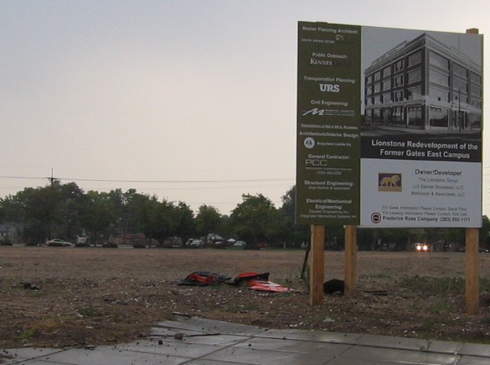

When, Cherokee bought its property in 2001, the Denver Labor Federation-affiliated Front Range Economic Strategy Center formed the Campaign for Responsible Development, a broad coalition of neighborhood, labor, disabled, and environmental groups to influence its plans. With financial support from Making Connections Denver, the Campaign now brings together 55 diverse organizations.
In 2003 the coalition contacted Cherokee. Over a three-year period it extracted a series of promises, embodied in a series of complementary, enforceable Community Benefits Agreements. In turn it backed Cherokee’s zoning proposal as well as subsidies, from the City and County of Denver, which should total $126 million.

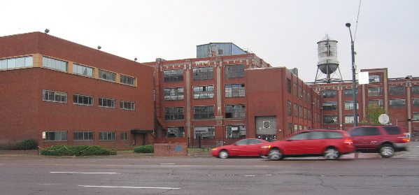

Cherokee plans an eight-million-square-foot mixed-used residential, office, and commercial complex, fronting an already operating light-rail station connecting directly to downtown Denver. It has pledged local hiring, prevailing wages for construction workers, no big-box stores, parks and open space, and wheelchair friendly facilities. Plans call for 200 affordable rental housing units and 150 affordable ownership residences.
Not surprisingly, the Gates site is contaminated. Among its problems are three TCE plumes, though the company reportedly blames Samsonite, which leased the eastern parcel. TCE was originally discovered by workers drilling for the light rail construction project. One plume has migrated under Interstate 25 into the West Washington Park neighborhood, along South Lincoln Street. At the insistence of community activists, officials and the responsible parties have installed monitoring wells and sampled air—indoors, subslab, and outdoors—in the residential area. Groundwater concentrations of TCE on Lincoln Street exceed the MCL (maximum contaminant level) of 5 parts per billion, but in most cases they aren’t much higher than that level. Furthermore, groundwater at the site does not serve as a source of drinking water.”
U.S. EPA and Envirogroup, on behalf of Gates and Cherokee, have sampled indoor air and soil gas at 53 homes. The Colorado Department of Public Health and the Environment (CDPHE) concluded that indoor air levels of TCE “are safe and do not pose a health risk to residents.” At least one home registered indoor air readings above the .8 micrograms per cubic meter (µg/m³) Colorado screening level, requiring further investigation. However, Colorado’s current action level—that is, for requiring mitigation such as subslab ventilation—is 1.6 (µg/m³). Before activists met with the CDPHE, the trigger level was even higher.
Personally, I don’t believe the 1.6 (µg/m³) action level is stringent enough. In fact, I believe that the Denver-area residential indoor air background level of .46 (µg/m³) poses an unacceptable risk to the entire population. Nevertheless, Cherokee and Gates, under CDPHE supervision, are aggressively treating the source areas with in situ technologies. According to CDPHE, TCE concentrations in those areas “have decreased up to 99%.” So, even though I question the finding that residents are safe, the response of groundwater cleanup makes better sense than installing mitigation systems (such as subslab depressurization) in neighboring homes.

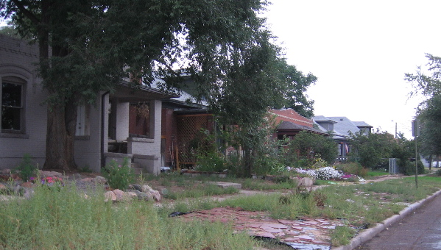

South Lincoln Street

Since 2005, a number of members of the Campaign have been meeting as the Voluntary Cleanup Advisory Board (VCAB). Cherokee is enrolled in Colorado’s Voluntary Clean-Up Program (VCUP), which has not required public participation or even notice. The VCAB has negotiated with CDPHE and Cherokee to receive notice of each cleanup plan that Cherokee submits for the Gates site, as well as the creation of a document depository in a local library. Now the VCAB is working with state legislators to propose that the state incorporate public involvement into the VCUP statute or regulations.
Demolition has begun on parts of the Gates complex, but it will take two or three years to properly remove and dispose of asbestos-containing materials. The Campaign and the VCAB intend to monitor and ensure Cherokee’s compliance with its agreements, but meanwhile, satisfied with the relationship it created based upon hard work and broad-based organizing, it is supporting Cherokee projects elsewhere in the Denver area.

For a more detailed description of the Campaign for Responsible Development’s achievements at Gates, as well as lessons learned, see “The Gates Cherokee Redevelopment Project: ‘A Huge Step Forward for the Low-Income People of Denver,’” by Tory Read, (Making Connections, August, 2006), a 1.6 MB PDF file, at http://www.cpeo.org/pubs/GatesMakingConnections.pdf.

