Disposal Gardens
Torrance, California
Lenny Siegel
May, 2006

On April 30, 2006, I visited the Disposal Gardens (an intriguing name, to say the least) site in Torrance, California. Also known as Torrance Sand and Gravel, Country Hills Tract Homes, and Rolling Hills Estates, the site covers 125 acres on the Palos Verdes Peninsula, south of downtown Los Angeles. My hosts, Joan Davidson and Claudia McCulloch, have earned their wings insisting on the cleanup and opposing the redevelopment of the adjacent Palos Verdes Landfill into a golf course.

Sand and gravel operations began in the 1920s, and according to the activists—citing long-time area residents—the Army began to dump wastes into the vast pits in 1941. It’s also possible that the Navy, which had massive industrial operations in Long Beach, disposed of waste there too. Officials aren’t sure about solid waste disposal, but their records show that large quantities of petroleum wastes were poured into sumps on the site. In addition, stormwater and wastewater was purposely diverted from the Palos Verdes Landfill onto the site, and Landfill leachate may also have migrated beneath the surface. California’s Department of Toxic Substances Control has documented that the Palos Verdes Landfill is leaking offsite into the surrounding community.

In the early 1970s the city of Torrance approved a development plan for the site that included filling the 100-foot deep gravel pits and mixing waste oil with sand as fill. Today the site includes a shopping center, a park, and $900,000 homes. The Country Hills Tract, built from 1972-78, has 450 homes as well as other connecting streets that were built at the same time by other builders.

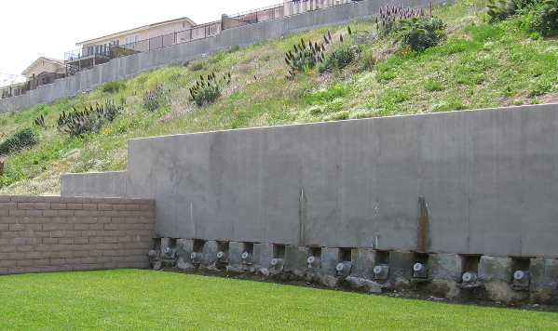

Since construction, the subdivision has been plagued with collapsing hillsides, cracking foundations and driveways, and discolored water bubbling up into basements and garages. In 2001 there was a major landslide that affected 24 homes. Residents reportedly had to spend over $150,000 per home, without government assistance, to erect enormous concrete walls with steel reinforcement beams bolted into the steep hillside.

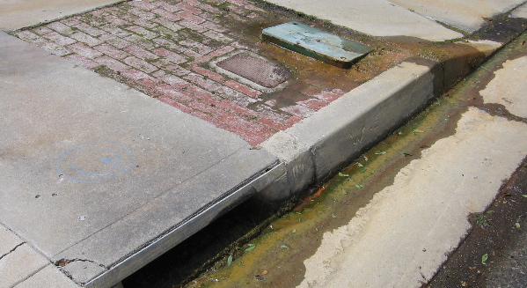

In August, 2005 representatives of the California Integrated Waste Management Board, which oversees landfills, came down to Torrance to meet with residents. The agency developed a workplan to sample for landfill gases, and it conducted those tests in March, 2006. As far as I know, the results have not yet been released.

To the casual observer, Country Hills looks like any other middle-class subdivision. But if one looks closely, there are massive retaining walls behind many of the homes, discolored concrete, and unknown liquids emerging from the ground. It is striking that as recently as the mid-1970s, a developer was allowed to build and sell housing on such a messy piece of property And it’s surprising that such a subdivision, built on petroleum wastes, ended up with affluent residents. It’s not surprising, however, that many have taken the developers to court.

